Telnet Enumeration Report (Port 23)

Author: Stanley Ebiwanno(HACKORAMA-HUB)
Role: Security Analyst
Date: November 2025

Objective

The goal of this assessment was to enumerate, analyze, and document the Telnet service running on port 23 of a target machine. This report includes methodology, screenshots, findings, analysis, and recommendations.

Tools Used

Nmap – Port scanning and service detection
Telnet Client – Banner grabbing and interaction
Linux Terminal – Command execution
Screenshots – Visual evidence of findings

Methodology

Conducted an Nmap scan targeting port 23.
Connected to the Telnet service to capture banners.
Collected screenshots of key outputs.
Analyzed security implications of Telnet being enabled.

Enumeration Results

Nmap Scan

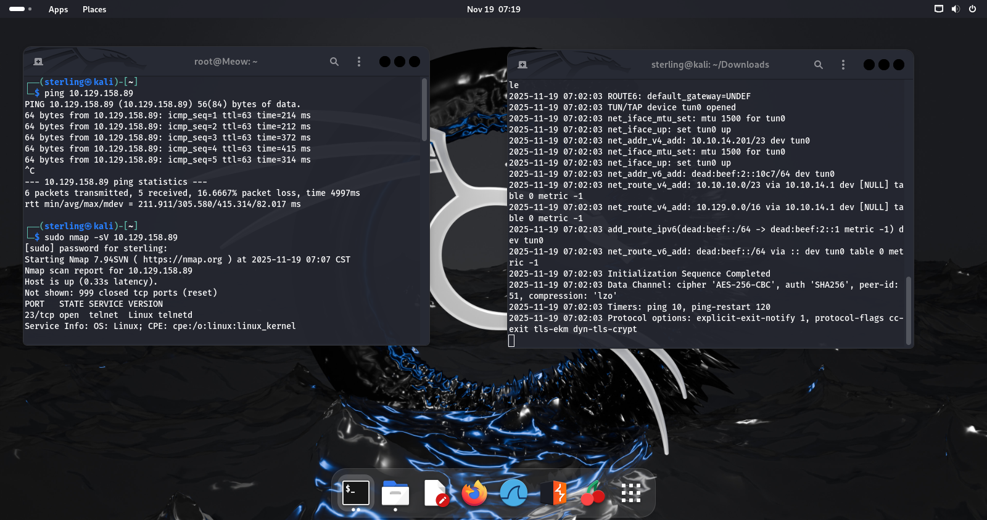
This scan identified port 23/tcp as **open**, showing that the Telnet service is active.

Telnet Banner
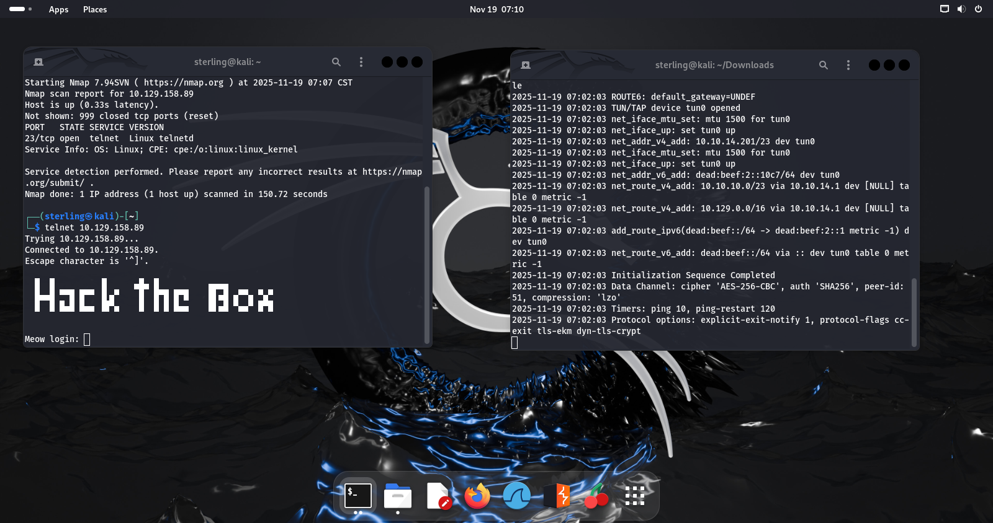
Upon connecting to the Telnet port, the service banner was captured for analysis.

Analysis

Telnet communicates in plaintext, exposing usernames and passwords if intercepted.
The service provides minimal authentication protection.
The presence of Telnet indicates outdated or misconfigured systems.
Recommendations

Disable Telnet and replace with SSH (port 22) for encrypted communication.
Implement strong authentication policies.
Monitor network logs for suspicious login attempts.
Apply network segmentation to isolate legacy services.

Conclusion

This exercise demonstrates that Telnet poses significant security risks due to its unencrypted nature and outdated protocols. Enumerating port 23 provides valuable experience in identifying insecure services during penetration testing.

Appendix

Include raw command outputs here when needed.

nmap -sV -p23 10.129.158.87
telnet 10.129.158.87 23

